A member Function that has the same name as the class name. It is automatically called when object of a class is created in main. The constructor has no return type that means it cannot return any value.
They should be declared in the public section.
  
They are invoked automatically when the objects are created.
- They do not have return type, not even void.
- They cannot be inherited, though a derived class can call the base class constructor.
- Like other c++ functions, they can have default arguments.
- Constructors cannot be virtual.

Constructors are of 3 types

- Default Constructor
- Parameterized Constructor
- Copy Constructor

- Default Constructor
    - Default Constructor: A constructor that accepts no parameters is called the default constructor.

2. Parameterized Constructor
- The constructors that take parameters are called parameterized constructors.
Syntax

- Copy Constructor
- A copy constructor is used to declare and initialize an object from
another object.

Syntax

Class_name object_name(parameter)
Class_name object_name=second_obj_name(parameter)

Program Default Constructor
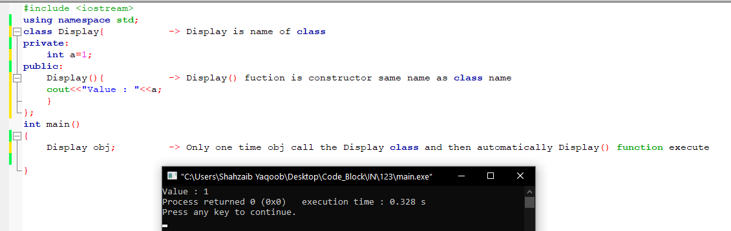

Code

Constructor overloading
The process of declaring multiple constructor with same name but different parameters. The constructor with same name as class name but it has must differ.
- Number of parameters
- Type of parameters
- Sequence of parameters
Syntax
Name(parameter)
{
Different Parameter or Data type
}

Syntax
Class Name
class Name
{
Constructor
Name()
{

Body of Member function constructor
}
Name(parameter)
Different Parameter or Data type
{

Body of Member function constructor
}

};
Program
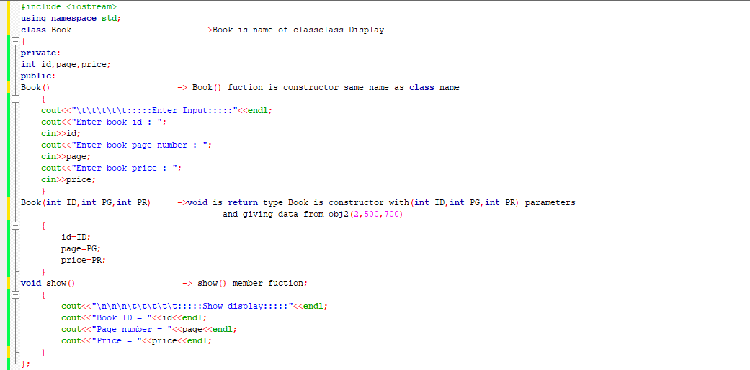
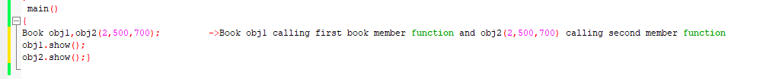
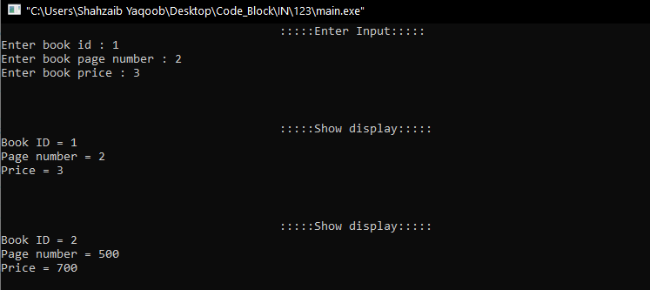

Code

Default Copy Constructor
We initialize the object with another existing object of the same class type for example Book is class name and it have three object obj1 , obj2 and obj3.
Book obj2( obj1 ) obj2 copy the all data of obj1
Book obj3=obj1 obj3 copy the all data of obj1

Syntax
Class_name object_name(parameter)
Class_name object_name=second_obj_name(parameter)

Program
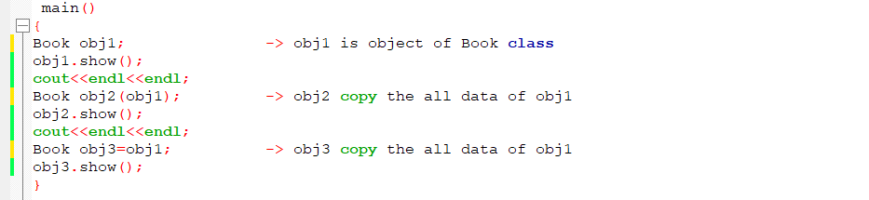
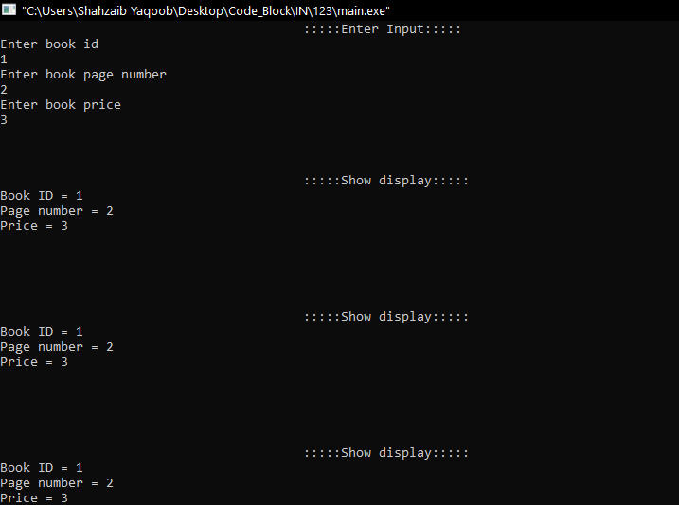

Code

Destructor

Destructor has no return type and its name is same name as class name but it is automatically executed when an object of the class is destroyed. It cannot accept any parameter.
Syntax
~name( )
{
Destructor

Body

}
Syntax
Class Name
class name{
Constructor
public:
name( ){

Body of Constructor
Destructor
}
~name( ){

Body of Destructor

}
};

Program
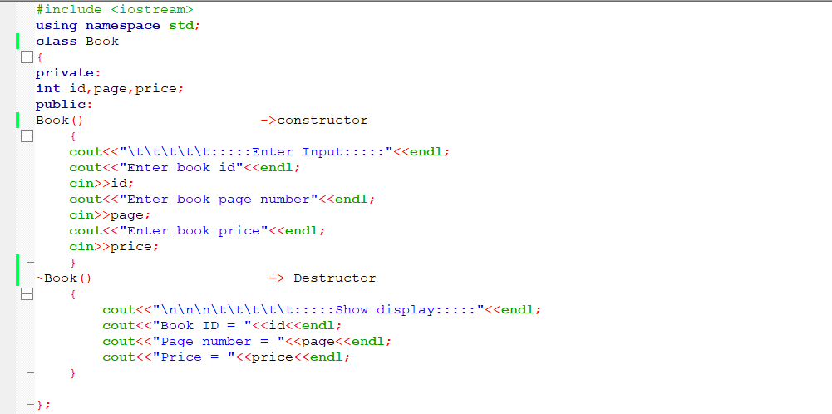
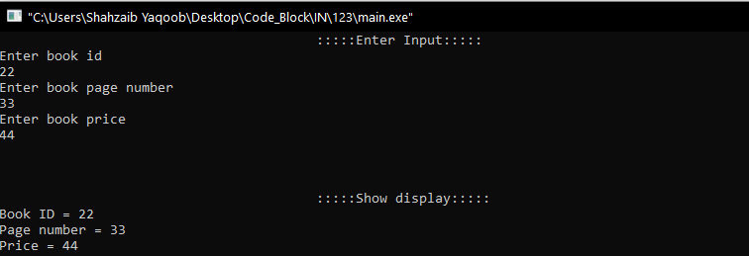

Code

Friend Function

A type of function that has access the private, protected, and public members of a particular class from outside the class. A friend function is used to access all the non-public members of a class. You can use a friend function to bridge two classes by operating objects of two different classes. The private and protected members of any class cannot be accessed from outside the class. In some situations, program may require to access these members. The use of friend’s functions allows the user access these members. A function that is declared in class with friend keywords become the friend function of the class.
Program
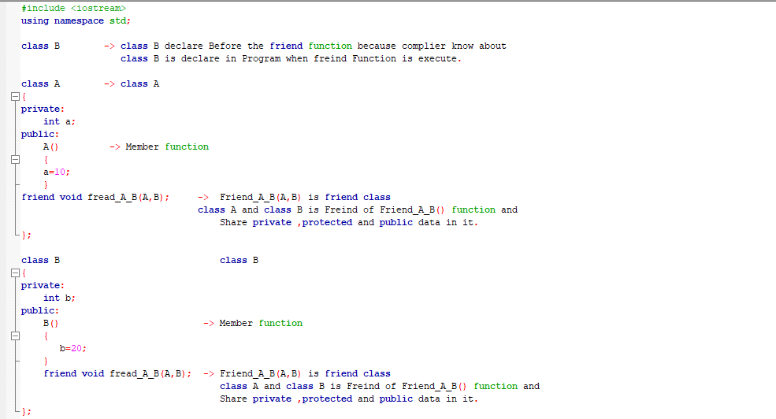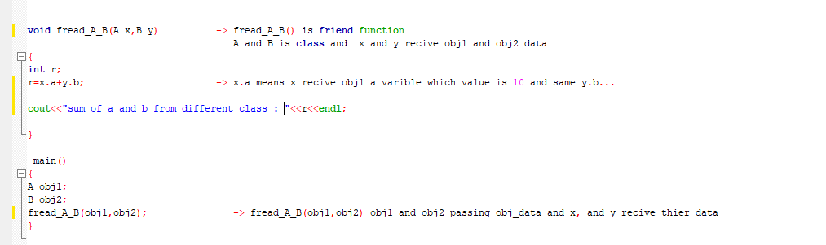
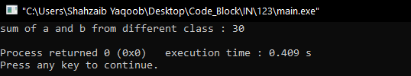

Code

Friend Class
A Class all of whose member function are allowed to access the private and protected members of a particular class. The private and protected members of any class cannot be accessed from outside the class. In some situations, program may require to access these members. The use of friend’s functions allows the user access these members. A function that is declared in class with friend keywords become the friend function of the class.
Code

Operators overloading
The process of declaring multiple Member function with same name but different parameters.
- Number of parameters
- Type of parameters
- Sequence of parameters
Syntax
Name(parameter)
{
Different Parameter or Data type
}

Syntax
Class Name
class Class_Name
Default Member function
{
Member_function()
{
Operators Overloading

Body of Member function constructor
}
Member_function (parameter)
Different Parameter or Data type
{

Body of Member function constructor
}

- };

